1) Write a query that will give you all orders for more than Rs. 1000

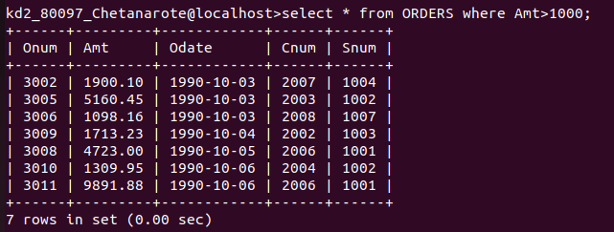

2) Write a query that will give you the names and cities of all salespeople in London with a commission above 0.10

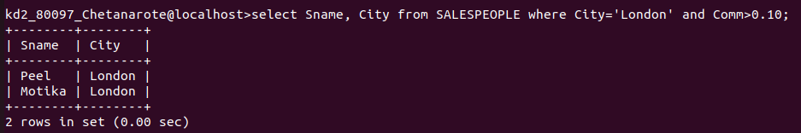

3) Write a query on the Customers table whose output will exclude all customers with a rating <= 100, unless they are located in Rome.

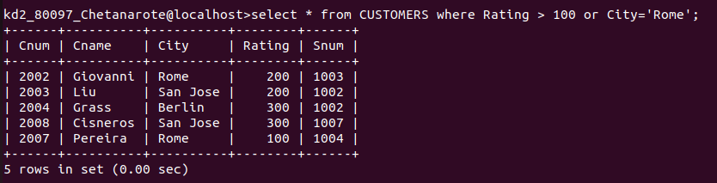

4) What will be the output from the following Query?
Select * from Orders where (amt <1000 OR NOT (Odate = '1990-10-03' AND Cnum > 2003));
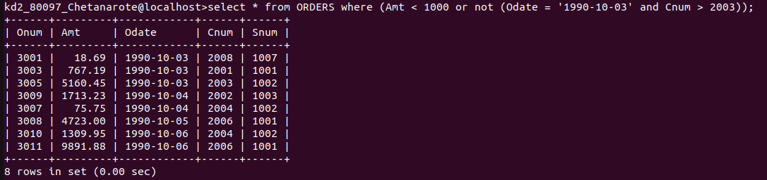

5) What will be the output of the following query?
Select * from ORDERS where not ((Odate = '1990-10-03' or Snum > 1006) and amt >= 1500);

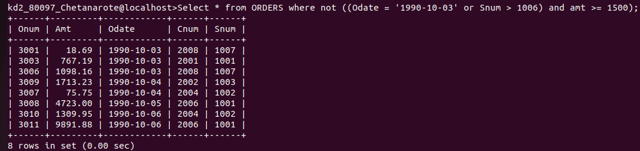

6) What is simpler way to write this query?
Select Snum, Sname, City, Comm from SALESPEOPLE where (Comm> 0.12 or Comm <0.14);
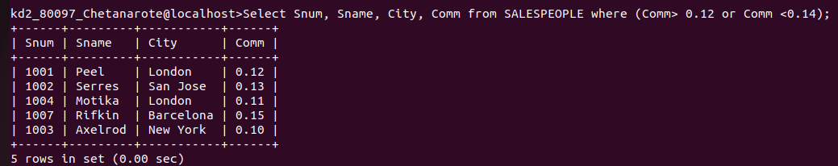

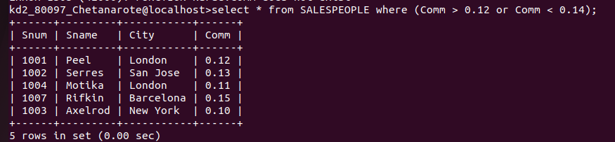
Simpler way to write above query

